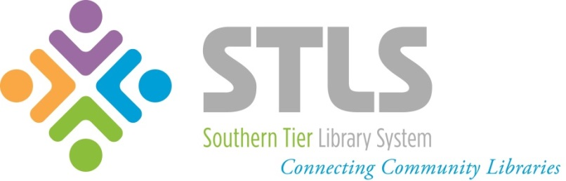
2018-2020 New York State
Public Library Construction Aid

Southern Tier Library System’s
Notification of Intent to Apply

$885,000 Available for Chartered Libraries in the Southern Tier Library System
Funding Information
New York State has approved $34 million in capital funds for public library construction. Chartered libraries in the STLS region, must apply through STLS, using the timeline below.
The minimum project amount is $5,000. All STLS member libraries qualify for a 75% funding match, but the library must have the 25% in matching funds available at the time of application. Decide the amount requested carefully – the library can’t appeal for more funds and is also required to completely expend the funds as described in the application. The amounts of funds awarded to each library will depend on the pool of applicants and funding priorities (see attached Eligibilities, Guidelines, and Priorities).
Routine maintenance is not an eligible expense, including replacement of carpeting, roof repair, repainting, refinishing, repointing, etc. New books or other library materials are also ineligible expenses for this program.
In order to apply for Construction Aid in 2018, please submit the following to Margo Gustina via email (gustinam@stls.org) or STLS Delivery (attn.: Margo) by July 2nd, 2018:
- This form (Notification of Intent to Apply)
- Facility Plan (can be of your own making or use the attached Member Library Facility Plan template)
- Contractor bid/quote (submit only one – it can be informal, but needs to be in writing)
- State Historic Preservation Office approval if your library is more than 50 years old
  - Requests for approval must be made through the CRIS online portal: https://cris.parks.ny.gov
    - Use CRIS as a GUEST if you don’t have a current account
    - Select Submit from the top bar menu (unless you have a number with SHPO)
    - Choose Consultation Project from the list of wizards on the Submit page
  - Receipt of this mandatory letter can take weeks or months – don’t delay!
- If the library doesn’t own the building or land, it must certify that the lease agreement stands for a minimum of 10 years from the anticipated date of project completion.
STLS timeline for 2018 - 2019 Construction Aid applications
Monday, April 30th: Webinar on Construction Aid. Register here: https://tinyurl.com/y9npe63j
Monday, July 2nd: Member library deadline to submit Intent to Apply packet to Margo
Week of July 9th (exact date/time TBD): Member library presentations to STLS Trustees
Tuesday, July 17th: STLS Board of Trustees votes and recommends awards. Applicants notified.
Friday, September 7th: Complete applications filed online by member libraries.
April - September 2019: New York State announces successful applicants and issues funds to libraries.
For more information visit http://www.stls.org/construction-aid, or contact Margo Gustina, gustiman@stls.org.
Application Form on the reverse…
Application Form
Director Name: _____________________________________________________________________________
Library: ____________________________________________________________________________________
Library FEIN#/SED vendor #: ___________________________________________________________________
Describe the project in one sentence: ____________________________________________________________
Describe the project briefly but completely: _______________________________________________________ ___________________________________________________________________________________________
___________________________________________________________________________________________
___________________________________________________________________________________________
___________________________________________________________________________________________
How will this project improve service to community members? _______________________________________
___________________________________________________________________________________________
___________________________________________________________________________________________
If the project is funded, when will it begin?____________ ? End? _________________(month approximations)
This year’s total cost of project: _______________________________________________________________
Funding requested (eligible for up to 75% of Cost): _________________________________________________
Was this project identified through the STLS Coordinated Facilities Planning program? _____ Yes ______ No
If awarded funding through the NYS Construction Aid to Public Libraries program, the library will begin the project by October 30th, 2019 and complete the project within 1 year of project start.
Name of Library Director |  | Name of Library Board President
Signature of Library Director |  | Signature of Library Board President

For more information visit http://www.stls.org/construction-aid, or contact Margo Gustina, gustiman@stls.org.

