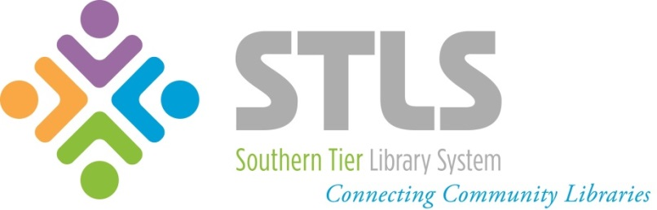
2019-2021 New York State
Public Library Construction Aid

Southern Tier Library System’s
Notification of Intent to Apply

$72,000 Available for Chartered Libraries in the Southern Tier Library System
Funding Information
While New York State has approved $14 million in capital funds for public library construction (2009 funding levels), STLS is committed to the completion of member library projects already underway in our communities. The remaining funding available for applications this year is $72,000.
The minimum project amount is $5,000. While all STLS member libraries qualify for a 75% funding match, due to reduced funding, libraries should anticipate covering more of the match if necessary. Decide the amount requested carefully – the library can’t appeal for more funds and is also required to completely expend the funds as described in the application.
Routine maintenance is not an eligible expense, including replacement of carpeting, roof repair, repainting, refinishing, repointing, etc. New books or other library materials are also ineligible expenses for this program.
In order to apply for Construction Aid in 2019, please submit the following to Brian Hildreth via email (communitylibrarypartner@stls.org) or STLS Delivery (attn.: Brian) by June 9th, 2019:
- This form (Notification of Intent to Apply)
- Facility Plan (can be of your own making or use the attached Member Library Facility Plan template)
- Contractor bid/quote (submit only one – it can be informal, but needs to be in writing)
- State Historic Preservation Office approval if your library is more than 50 years old
  - Requests for approval must be made through the CRIS online portal: https://cris.parks.ny.gov
    - Use CRIS as a GUEST if you don’t have a current account
    - Select Submit from the top bar menu (unless you have a number with SHPO)
    - Choose Consultation Project from the list of wizards on the Submit page
  - Receipt of this mandatory letter can take weeks or months – don’t delay!
- If the library doesn’t own the building or land, it must certify that the lease agreement stands for a minimum of 10 years from the anticipated date of project completion.
STLS timeline for 2019 - 2020 Construction Aid applications
Wednesday, May 8th: Webinar on Construction Aid. Register here: http://tinyurl.com/yytpcjqy
Sunday, June 9th: Member library deadline to submit Intent to Apply packet to Brian
Monday, June 17th: Member library presentations to STLS Trustees
Tuesday, July 18th: STLS Board of Trustees votes and recommends awards. Applicants notified.
Monday, September 2nd: Complete applications filed online by member libraries.
April - September 2019: New York State announces successful applicants and issues funds to libraries.
For more information visit http://www.stls.org/construction-aid, or contact Brian Hildreth, communitylibrarypartner@stls.org.
Application Form on the reverse…
Application Form
Director Name: _____________________________________________________________________________
Library: ____________________________________________________________________________________
Library FEIN#/SED vendor #: ___________________________________________________________________
Describe the project in one sentence: ____________________________________________________________
Describe the project briefly but completely: _______________________________________________________ ___________________________________________________________________________________________
___________________________________________________________________________________________
___________________________________________________________________________________________
___________________________________________________________________________________________
How will this project improve service to community members? _______________________________________
___________________________________________________________________________________________
___________________________________________________________________________________________
If the project is funded, when will it begin?____________ ? End? _________________(month approximations)
This year’s total cost of project: _______________________________________________________________
Funding requested (eligible for up to 75% of Cost): _________________________________________________
Was this project identified through the STLS Coordinated Facilities Planning program? _____ Yes ______ No
If awarded funding through the NYS Construction Aid to Public Libraries program, the library will begin the project by October 30th, 2020 and complete the project within 1 year of project start.
Name of Library Director |  | Name of Library Board President
Signature of Library Director |  | Signature of Library Board President

For more information visit http://www.stls.org/construction-aid, or contact Brian Hildreth, communitylibrarypartner@stls.org.

